AI Online Assistant – Fake News Detector

### Epi-Use Africa

# 5Bits

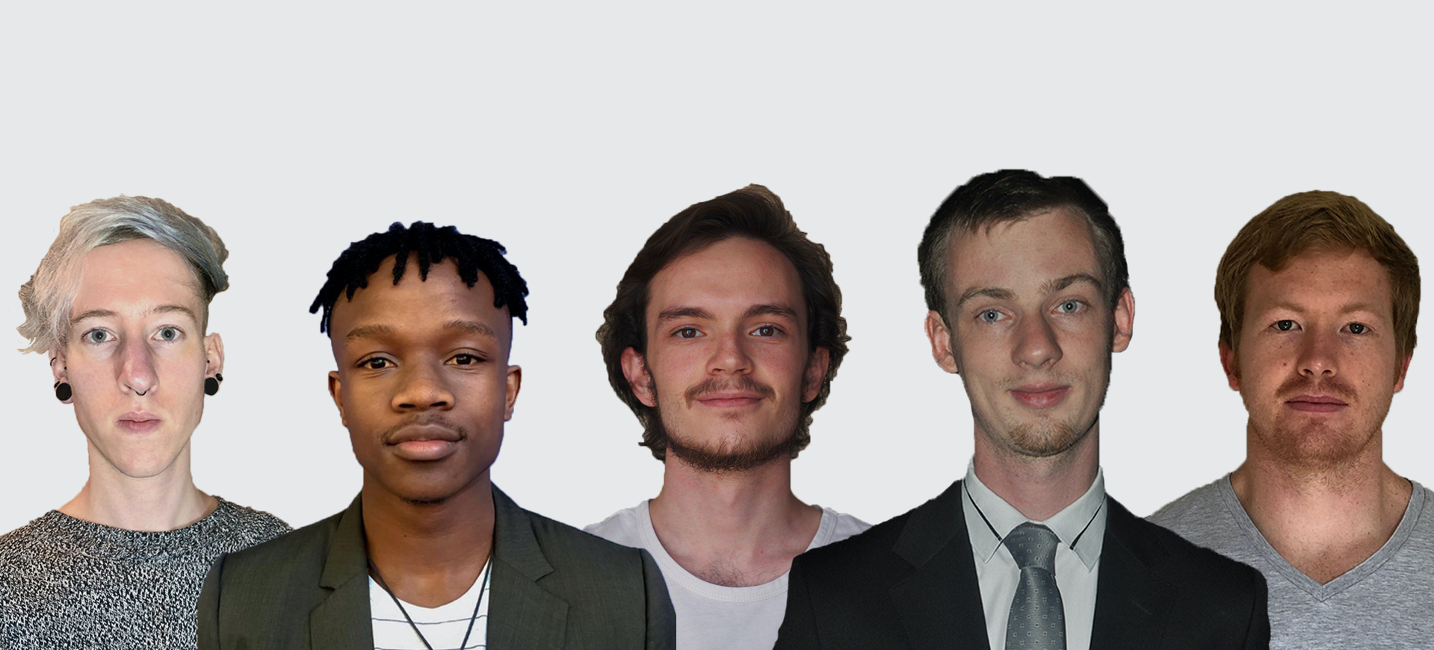

|  |  |  |
| --- | --- | --- |
| **Our Team (Left to Right)** | | |
| **Name** | **Email** | **Student Number** |
| Danré Retief | [u14126461@tuks.co.za](mailto:u14126461@tuks.co.za) | 14126461 |
| Thato Tshukudu | [u18010408@tuks.co.za](mailto:u18010408@tuks.co.za) | 18010408 |
| Quinton Coetzee | [u18028510@tuks.co.za](mailto:u18028510@tuks.co.za) | 18028510 |
| Stuart Barclay* | u15015069@tuks.co.za | 15015069 |
| Alistair Payn | [u14272289@tuks.co.za](mailto:u14272289@tuks.co.za) | 14272289 |

## [*] - team leader

## Project Description

One of the biggest problems we face in the information age is fake news. It can easily misinform and thereby misguide important decisions. That is where the Fake News Detector comes in. The fake news detector will be deployed as a browser plugin, as well as possibly a plugin for email clients and a facebook app, as all three of these serve as platforms for news consumption. These plugins will rely on a web server, which will be used to train the models to be used in detecting fake news.The web server will also host databases of known fake news sources and articles. Though the server will do the bulk of the back-end work, some of the functionality will also be incorporated directly into the plugins. Furthermore feedback from the community will be welcomed, but critically analyzed to ensure that the feedback itself does not promote any agenda that can lead to more fake news.

## Domain Model of Fake News Detector

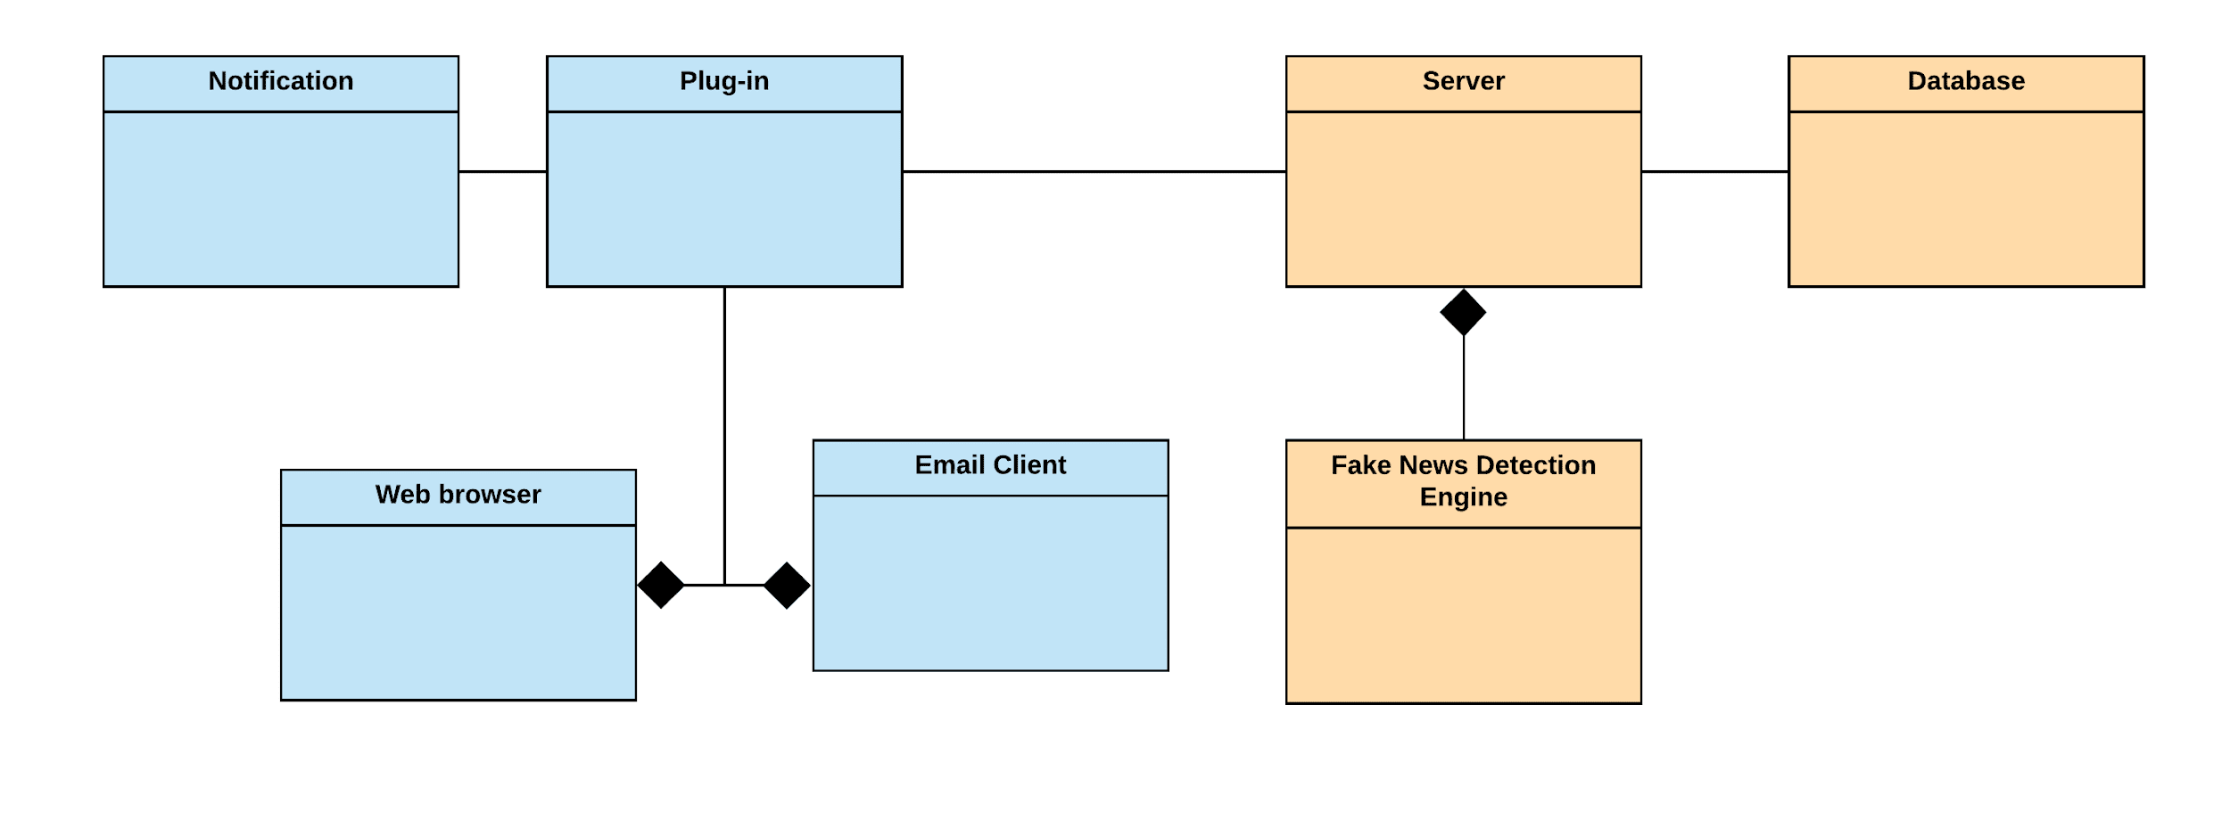

## Technologies We’ll Use

* **Python:** Python is simple yet powerful and has extensive pre-existing open source libraries that will help specifically with this task. We intend to use Python for our backend architecture as it is an ideal server language. The libraries we are looking at include the following:
  + **Tensorflow:** We are looking at Tensorflow to implement the machine learning component of the system. We chose Tensorflow instead of Pytorch because we are familiar with it and it is powerful enough to create the machine learning models needed for the fake news detection. We believe the differences between Tensorflow and Pytorch are negligible. That being said Tensorflow also has the largest community which will aid us, should we get stuck.
  + **Keras:** We will consider using Keras on top of Tensorflow as this will allow us to better fine tune the machine learning models based on the success that various parameter adjustments bring. We are however aware that the use of Keras takes away certain Tensorflow functionality and we will therefore decide on the use of keras after we have cleared up some project specific details.
* **Python for API’s:** We will use Python to provide restful API’s to the browser plugin.
* **Postgres DB:** We prefer Postgres DB to other DBMS because we like the community around it and find the syntax more usable.
* **Angular:** We would like to use Angular where frontend development is concerned. We are aware of the simplicity offered by Vue, but we appreciate the maturity of the Angular framework. This maturity comes with a large community as well. This will primarily be used to design the browser plugin.

Deployment will be discussed at a later stage once project specific details have been cleared up. In the same vein, the aforementioned technologies are subject to change as more information comes to light during user story workshops etc.

## Development Methodology

SCRUM is a lightweight process framework for Agile development. It is often used to manage complex software and product development using iterative and incremental practices.

Our team will operate in development cycles referred to as “Sprints” during which we will develop aspects of the system within a fixed time-box. Most of our sprints will be about 10 days in length, as this is a tried and tested amount of time to work effectively without getting too comfortable. This may vary slightly depending on the specific problem/user story to which a sprint is dedicated.

Our team chose this methodology due to its benefit of allowing the team to cope effectively with change, to be responsive to requests and to be in better control of the project schedule and state. As a result, this methodology enables our team to engage in frequent meetings for task planning and tracking, weekly reviews and Sprint retrospectives.

As the Product Owner, Epi-Use Africa, your role is to provide the Team, 5Bits, with the system requirements and developing a planned order of implementation for the project. During development your role will escalate to buffering features and bug-fix requests and being the single point of contact for all questions about product requirements. As the Product Owner, you retain the authority of setting the schedule for release of the completed system if you deem it to have satisfied the feature and quality requirements.

## 5Bits: Detailed

### Stuart Barclay

|  |  |
| --- | --- |
| Current Skills and Knowledge | * BA Sport Psychology Completed 2017 at University of Pretoria. * Strong debugging and attention to details abilities. * AI and Security are some of my interests. * Proficient in C++, Java and Python * Proficient in both frontend and backend web-development technologies (React, C# MVC, HTML/CSS/JS and PHP Stack) NodeJS. * Proficient in MongoDB, SQL, MySQL |
| Application of Skills | * I have a large amount of experience with a multitude of different technologies. I am always willing to learn a new way of doing something and how the technology works. * I like to lead by example, keep the team happy and motivated, - something I learnt from my previous degree a happy team is one that works a lot more efficiently and effectively. |

### Quinton Coetzee

|  |  |
| --- | --- |
| Current Skills and Knowledge | * Extensive knowledge of most major frontend and backend languages. * Testing and debugging. * Excellent problem-solving skills and determination. * Project management and planning. * Leadership and diplomacy. * Soft skills like communication. * Photography and cinematography. * Graphic design. * Machine Learning and neural networks. |
| Application of Skills | * Programming knowledge including languages, frameworks and debugging skills that I already know, as well as an intense willingness to learn new programming skills will allow me to work hard and complete any aspect of the coding project. * Interpersonal skills will allow us to work well in a team to keep one another motivated and ensure that we work hard from the offset and throughout. * Years of photography and cinematography experience will allow me to create striking imagery which can be used especially on the front end side of things to stand out. |

### Alistair Payn

|  |  |
| --- | --- |
| Current Skills and Knowledge | * BSc Geology from the University of the Witwatersrand. * Proficient at problem solving. * Broad knowledge and experience solving problems in many scientific fields such as: Geology, Chemistry, Mathematics, and Computer Science. * Written and verbal communication. * Proficient at adapting and applying skills to new problems and fields. * Proficient at programming, testing and debugging. * Full stack development (C, C++, Java/Android, JavaScript/TypeScript, PHP, HTML5, CSS, SQL, Node). * Frameworks (Qt, Flutter). * Linux server setup and maintenance. |
| Application of Skills | * Creative problem solving in a broad range of scientific fields will be applied to modeling, designing, and programming the AI aspects of the project. * Experience in scientific writing can be applied to creating good software documentation. * Experience in adapting to different fields will be used to adapt and overcome new challenges associated with the project. |

### Danré Retief

|  |  |
| --- | --- |
| Current Skills and Knowledge | * Multimedia, Informatics and Computer science. * Language and communication skills (English, German, Afrikaans). * UX design. * Javascript/Typescript frontend frameworks (Angular/Vue) and progressive web apps (Ionic/Electron). * Backend programming (PHP, C#, Python[Django], Javascript[Node]). * Relational databases. |
| Application of Skills | * Creative approach to problem solving and formal training in multimedia, web design and human-computer interaction can be applied to design aspects of the project. * Aptitude for communication and problem solving will aid in team coordination and finding solutions. |

### Thato Tshukudu

|  |  |
| --- | --- |
| Current Skills and Knowledge | * Computer programming and coding (with strengths in web development). * Unit testing and debugging. * Problem solving and logical thinking. * Written and verbal communication. * Interpersonal skills in teamwork. * Organization and scheduling. |
| Application of Skills | * My current programming skills and ones that will be developed through learning new frameworks and languages will be used for the code implementation aspect of the project. * I will be able to automate tests for various components of the application. * My capability in thinking logically will contribute to the team’s effort to creating a good software solution. * My communication skills may be used to bridge communication between the client and the team or between me and one of my team members. * Interpersonal skills will be used to develop cohesion with other members of the team. * My organization skills will assist me in managing my tasks and deadlines. |

## 

## Possible Shortcomings

**What we’re missing:**

Project specific experience. Seeing as none of us have created a fake news detector before, we are not yet subject experts in the fake news world. We have also never created a browser plugin before and therefore do not yet exactly know how to do it.

**How we’ll get it:**

Dedicated research. We are all motivated and excited to learn about both fake news and browser plugins, as we believe that these are valuable skills to have. We look forward to becoming experts in this field and using the knowledge we gain to solve this real world problem.

**What we’re missing:**

Chemistry as a group. Though most of us have worked together to some extent in the past and we all find one another pleasant, we have not yet worked as a group on a large project. We recognise that it can be difficult to work as a team on any large project.

**How we’ll get it:**

Contact time. We will have weekly meetings to discuss the project and check in on our progress, these meetings will allow us a chance to build chemistry as a group and stay on track. As soon as we are allowed personal contact, we will also have regular get togethers and in person coding sprints on campus.

## Why You Should Choose 5Bits

Even though we have great technical skills and our team is made up of highly experienced individuals and multiple top achievers, we believe the reason you should choose 5Bits is passion. We take great pride in our work and set high standards for ourselves to achieve, not because we want to pass modules, but because we are passionate about software engineering and what we can achieve with it. Our willingness to learn, ask questions and to accept guidance when we need it will be paramount in this project. We believe that fake news poses an incredible threat to the free world and we are therefore grateful for the opportunity to tackle this problem with an effective browser plugin. That is why we chose your project and why we are hoping you choose us too.

 